

**CAPSTONE PROJECT 1**

**PROPOSAL DOCUMENT**

**Shared Space Finder-SSF**

**CODE:** PROPOSAL_v1

**DATE:** 03 Sep 2023

**Submitted by**

**Tran Quang Luan**

**Le Xuan Tan**

**Le Xuan Hoang**

**Nguyen Ba Phu Quy**

**Approved by Tran Kim Sanh**

**Proposal Review Panel Representative:**

**Name Signature Date**

**Capstone Project 1- Mentor:**

**Name Signature Date**

**Porject Information**

|  |  |  |  |  |  |
| --- | --- | --- | --- | --- | --- |
| **Project acronym** | SSF | | | | |
| **Project Tittle** | Shared Space Finder | | | | |
| **Start Date** | 03 Sep 2023 | | **End Date** | 11 Dec 2023 | |
| **Lead Institution** | International School, Duy Tan University | | | | |
| **Project Mentor** | MSc.Tran Kim Sanh  Email: sanhtk@gmail.com  Tel: 0987409464 | | | | |
| **Project Manager & contact details** | Tran Quang Luan  Email: [quangluantran123@gmail.com](quangluantran123@gmail.com%20)  Tel: 0834290477 | | | | |
| **Partner Organization** | Duy Tan University | | | | |
| **Project Web URL** |  | | | | |
| **Team members** | Name | Email | | | Tel |
| **26211235168** | Le Xuan Tan | <lexuantan159@gmail.com> | | | 0905242774 |
| **25211217171** | Le Xuan Hoang | xuanhoang012555555@gmail.com | | | 0945636978 |
| **26211235629** | Nguyen Ba Phu Quy | vuacatxe215@gmail.com | | | 0395945538 |

**Proposal Document**

|  |  |  |  |
| --- | --- | --- | --- |
| **Document Title** | Proposal | | |
| **Reporting Period** |  | | |
| **Author(s) & project** | C1SE.35Team | | |
| **Role** | Tran Quang Luan | Scrum Master | |
| Le Xuan Hoang | Product Owner | |
| Le Xuan Tan | Team member | |
| Nguyen Ba Phu Quy | Team member | |
| **Date** | 03 Sep 2023 | **Filename** | C1SE.35_ProjectProposal - SSF.docx |
| **URL** |  | | |
| **Access** | Project and CMU Program | | |

|  |  |  |
| --- | --- | --- |
| **Document History** | | |
| **Version** | **Date** | **Comments** |
| 1.0 | 03/09/2023 | Create Project Document |

**SIGNATURE**

**Document Approvals:** The following signatures are required for approval of this document.

|  |  |  |
| --- | --- | --- |
| Tran Kim Sanh  *Mentor* |  | Date |
| Tran Quang Luan  *Scrum master* |  | Date |
| Le Xuan Hoang  *Product Owner* |  | Date |
| Le Xuan Tan  *Team member* |  | Date |
| Nguyen Ba Phu Quy  *Team member* |  | Date |

**Table of Contents**

1. Introduction 1

1.1. Purpose 1

1.2. Scope 1

2. Project Overview 1

2.1. Project definition 1

2.2. Business needs/ User needs 1

2.3. Prior Art 2

2.4. Proposed Solution 3

**2.4.1.** **Project goal** 3

**2.4.2.** **System overview** 4

**2.4.2.1.** **System context** 4

**2.4.2.2.** **System context description** 4

2.5. Technical Constraints 5

3. Master Plan 5

3.1. Scrum Process 5

3.2. Master plan 7

4. Organization Management 7

4.1. Human Resource 7

5. Cost Estimation 8

6. Project Constraints 8

7. Conclusion 9

8. References 10

9. Attachment 10

DESCRIPTION OF PRODUCT REQUIREMENTS FORM 10

# **Introduction**

## **Purpose**

The purpose of the proposal is to:

* Define the business need and problem in detail.
* Provide solutions for business needs and show the overview of system architecture.
* Provide an overview of resources, schedule, solution, and budget for the project.

## **Scope**

This document provides an overview of the project. It includes the description of business needs, the proposed solution, the financial forecast, and some constraints that are involved in the project.

The document provides a comprehensive master plan for each phase of software development based on the processes that have been selected.

This document is made for senior management to put forward a proposal.

# **Project** **Overview**

## **Project definition**

We built the Shared Space Finder to help users proactively search for spaces that meet their needs. The project aims to provide businesses and individuals with convenience and affordable prices to find spaces that suit their needs.

The Shared Space Finder is a web-based platform that allows users to search for spaces by location, size, amenities, and price. Users can also filter their search results by date and time availability. Once a user has found an spaces that they are interested in, they can book it directly through the platform.

## **Business** **needs/ User needs**

The number of coworking spaces worldwide is estimated to reach approximately 20,000 this year and cross the 40,000 marks by 2024. In a time when digital distractions are always at arm’s length, an increasing number of freelancers and self-employed creatives are looking for a work environment outside of their own homes that offers them much-needed change, stability, motivation, and clarity. Thus, coworking spaces are quickly becoming tools for developing businesses that place efficiency over tradition.

To help individuals find co-working office spaces conveniently, we have designed Shared Space Finder. Our system can make it easier to find nearby coworking office spaces and one can look for the amenities offered by them within the system itself and find other useful information related to the spaces. Through the system, you should be able to maximize your time better and streamline the coworking space’s operations.

## **Prior Art**

|  |  |  |  |
| --- | --- | --- | --- |
| **Function** | **Shared Space Finder** | **thuecanho123.com** | **timtro.vn** |
| Users can view spaces details. | √ | √ | √ |
| Users can search for spaces | √ | √ | √ |
| Owners can post spaces rental information | √ | √ | √ |
| Users and owners can communicate with each other. | √ | N/A | N/A |
| Users can rent and then sublease another part of the space | √ | N/A | N/A |
| Users can rent a space together | √ | N/A | N/A |

## **Proposed Solution**

Today, more and more freelancers and self-employed creatives are looking for a work environment outside of the home that gives them change, stability, motivation, and clarity. It is clearly very necessary.

To help individuals find coworking spaces conveniently, we designed the Shared Space Finder System on the web. Our system can make it easier to find nearby workspaces. They can view the details of the available space for rent. The project aims to provide businesses and individuals with a convenient, affordable way to find space that meets their needs.

### **Project goal**

We will develop a system to help users easily find and book workspaces online, anytime, anywhere. The system will allow users to chat with space owners, view information about available spaces, such as size, location, and amenities, and book spaces directly. We aim to launch the system within 3 months with a budget of $4,000. This system will improve the flexibility and convenience of working for businesses and individuals, and help to reduce the cost of renting and maintaining workspaces.

### **System overview**

#### **System context**

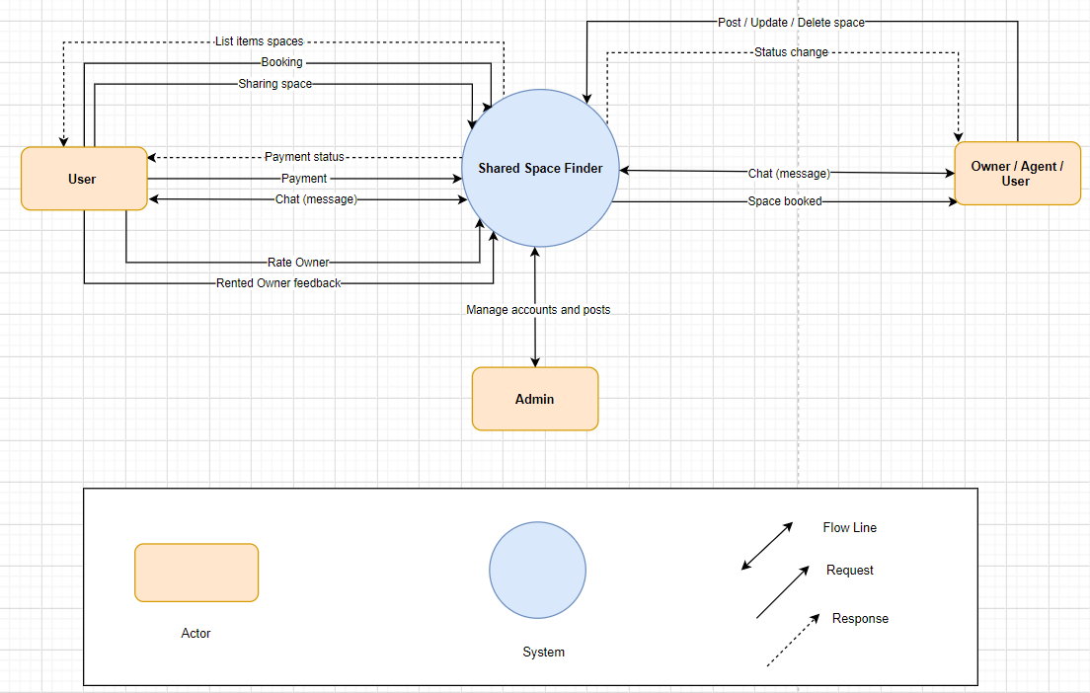

***Figure 2.6.1: System context overview***

#### **System context description**

* Owner/Agent has the responsibility to: To log into the system, the Owner/Agent must first register. They can manage their profile and change their password. They can add, update, delete, and view the space's details, as well as its features, such as availability and size, and assets, such as a projector and printer. They can charge a fee per hour to book the space. They need to add, update, delete, and view slot timing along with the available rooms. They can check the booking and accept or reject pending reservations. They can chat with the booked user as well as read the ratings and reviews about the space.
* The user has the responsibility to: To log in, the user would also need to register. Users are responsible for managing their profiles, searching for spaces, booking spaces, and viewing their booking history. They can also chat with the space owner after booking.
* Admin has the responsibility to: Manage users and posts.

## **Technical Constraints**

**Technical to develop:**

* Programming Language: HTML,CSS, JavaScript, Java.
* Framework: React, Spring-boot
* System: Windows.
* Develop tools: Visual Studio Code, IntelliJ IDEA.
* Database Management System: MySQL.
* Management Tool: Trello, Slack, Discord.
* Design Tool: Figma, Draw.io.
* Manage Source Code Tool: Git, GitHub.

**Business constraints**

* Resource: 4 people.
* Budget: 4000$.
* Time: The project must be completed within 03 months.

# **Master Plan**

## **Scrum Process**

We are using the Scrum process for this project because Scrum is an iterative and incremental agile software development framework for managing product development. It defines "a flexible, holistic product development strategy where a development team works as a unit to reach a common goal” challenges the assumption of the "traditional, sequential approach" to product development, and enables teams to self-organize by encouraging physical co-location or close online collaboration of all team members, as well as daily face-to-face communication among all members.

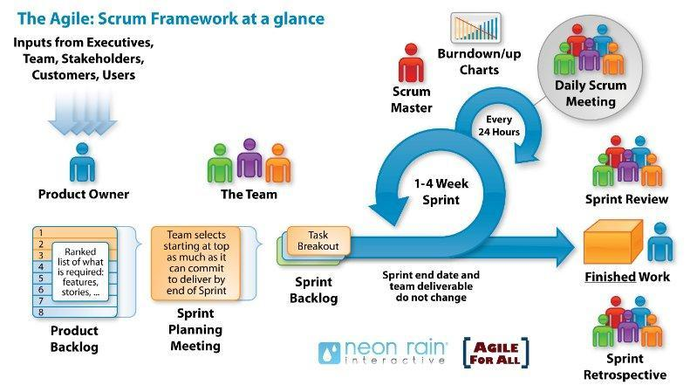

***Figure: General SCRUM Process***

* Scrum is an iterative and incremental agile software development framework for managing software projects and product or application development.
* Scrum focuses on project management institutions where it is difficult to plan ahead.
* Mechanisms of empirical process control, where feedback loops that constitute the core management technique are used as opposed to traditional command-and-control management.
* Its approach to planning and managing projects is by bringing decision-making authority to the level of operation properties and certainties.

## **Master plan**

|  |  |  |  |  |
| --- | --- | --- | --- | --- |
| **NO** | **Task Name** | **Duration** | **Start to** | **Finish** |
|
| 1 | **Start Up** | **12 days** | **03/09/23** | **14/09/23** |
| 1.1 | Project Kick Off Meeting | 1 day | 03/09/23 | 03/09/23 |
| 1.2 | Discuss project ideal | 2 days | 04/08/23 | 05/08/23 |
| 1.3 | Create Document for project | 9 days | 06/08/23 | 14/09/23 |
| 2 | **Development** | **84 days** | **15/09/23** | **07/12/23** |
| 2.1 | Sprint 1 | 28 days | 15/09/23 | 12/10/23 |
| 2.2 | Sprint 2 | 28 days | 13/10/23 | 09/11/23 |
| 2.3 | Sprint 3 | 28 days | 10/11/23 | 07/12/23 |
| 3 | **Project’s Meeting** | **1 day** | **08/12/23** | **08/12/23** |
| 4 | **Final Release** | **3 days** | **09/12/23** | **11/12/23** |

# **Organization Management**

## **Human Resource**

* Team’s Information

|  |  |  |  |
| --- | --- | --- | --- |
| **Full Name** | **Phone** | **Email** | **Position** |
| Msc. Tran Kim Sanh | 0987409464 | <sanhtk@gmail.com> | Mentor |
| Tran Quang Luan | 0834290477 | <quangluantran123@gmail.com> | Scrum Master |
| Le Xuan Tan | 0905242774 | <lexuantan159@gmail.com> | Product Owner |
| Le Xuan Hoang | 0945636978 | <xuanhoang012555555@gmail.com> | Team member |
| Nguyen Ba Phu Quy | 0395945538 | <vuacatxe215@gmail.com> | Team member |

# **Cost Estimation**

The following outlines the cost to complete all the identified components for the project.

|  |  |  |  |
| --- | --- | --- | --- |
| **No.** | **Phase** | **Milestone** | **Cost (USD)** |
| 1. | Start-up | STU | $384 |
| 2. | Development | SPR 1 | $896 |
| SPR 2 | $896 |
| SPR 3 | $896 |
| 3. | Other costs | OTH | $800 |
| 4. | Project’s Meeting | PM | $32 |
| 5. | Final Release | FR | $96 |
| 6. | **Total** | | **$4000** |

# **Project Constraints**

|  |  |  |
| --- | --- | --- |
| **Constraint** | **Constraints Description** | **Guidelines for Acceptance** |
| **Economic** | Cost for Project: 3200$ Other Cost : 800$  Total Cost: 4000$. | Elements for consideration are design costs, production costs, maintenance costs, operating costs, and sales price. |
| **Environmental** | N/A |  |
| **Ethical** | The absolute security of information for users is always a top priority.  The system does not exploit user information at all. Always ensure the safety of users. | Ethical considerations can be broad. Areas that are typically addressed include intellectual property, reverse- engineering, privacy, security, and the conflict between cost and safety |
| **Public health, safety, and welfare** | N/A |  |
| **Social and Global** | The system helps users find spaces in the most convenient way. Users can view spaces information. | Addresses aspects such as benefits, risks, the man-machine interface, the acceptance of products by the intended user or by society at large, and global and socially responsible engineering. |
| **Cultural** | N/A |  |
| **Sustainability** | Have a clear interface, user-friendly, color harmony. UI and the visual icon to help the user understand. Thread to ensure the the system works smoothly. Easy to reusability or maintainability. | Refers to the sustainability of resources, including material, energy, supplies, manufacturing techniques, personnel, operation, and the need for additional infrastructure, as well as the sustainability of the design including reliability, lifetime, durability, reusability, maintainability. |

# **Conclusion**

In fact, finding a space is inconvenient for some people for a variety of reasons. Therefore, our system is useful to help users find and share live space locations, exchange and make appointments to view shared spaces directly. The application is developed using the React framework with the Java programming language using the Spring Boot framework and MySQL as the database with the mission to bring great experiences to users and save them more time and effort. The project is expected to be completed in 100 days at a cost of $4,000.

# **References**

|  |  |  |
| --- | --- | --- |
| **No.** | **References** | **Document Information** |
| 1 | Scrum Model | <https://en.wikipedia.org/wiki/Scrum_(software_development)> |
| <https://www.atlassian.com/agile/scrum> |
| <https://www.digite.com/agile/scrum-methodology/> |
| [https://docs.microsoft.com/en-us/azure/devops/boards/sprints/b](https://docs.microsoft.com/en-us/azure/devops/boards/sprints/best-practices-scrum?view=azure-devops) [est-practices-scrum?view=azure-devops](https://docs.microsoft.com/en-us/azure/devops/boards/sprints/best-practices-scrum?view=azure-devops) |
| <https://www.scrum.org/resources/scrum-guide> |
| 2 | Technical | <https://spring.io/projects/spring-boot> |
| <https://react.dev/reference/react> |
| <https://www.mysql.com/> |
| 3 | Software Engineering Standards | [https://www.nws.noaa.gov/oh/hrl/developers_docs/General_So](https://www.nws.noaa.gov/oh/hrl/developers_docs/General_Software_Standards.pdf) [ftware_Standards.pdf](https://www.nws.noaa.gov/oh/hrl/developers_docs/General_Software_Standards.pdf) |
| <https://standards.ieee.org/standard/12208-2017.html> |
| <https://sw-eng.larc.nasa.gov/> |

# **Attachment**

# DESCRIPTION OF PRODUCT REQUIREMENTS FORM

